**Green Township Property Acquisition**

**Request for Qualifications**

**5565 Woodhaven Drive**

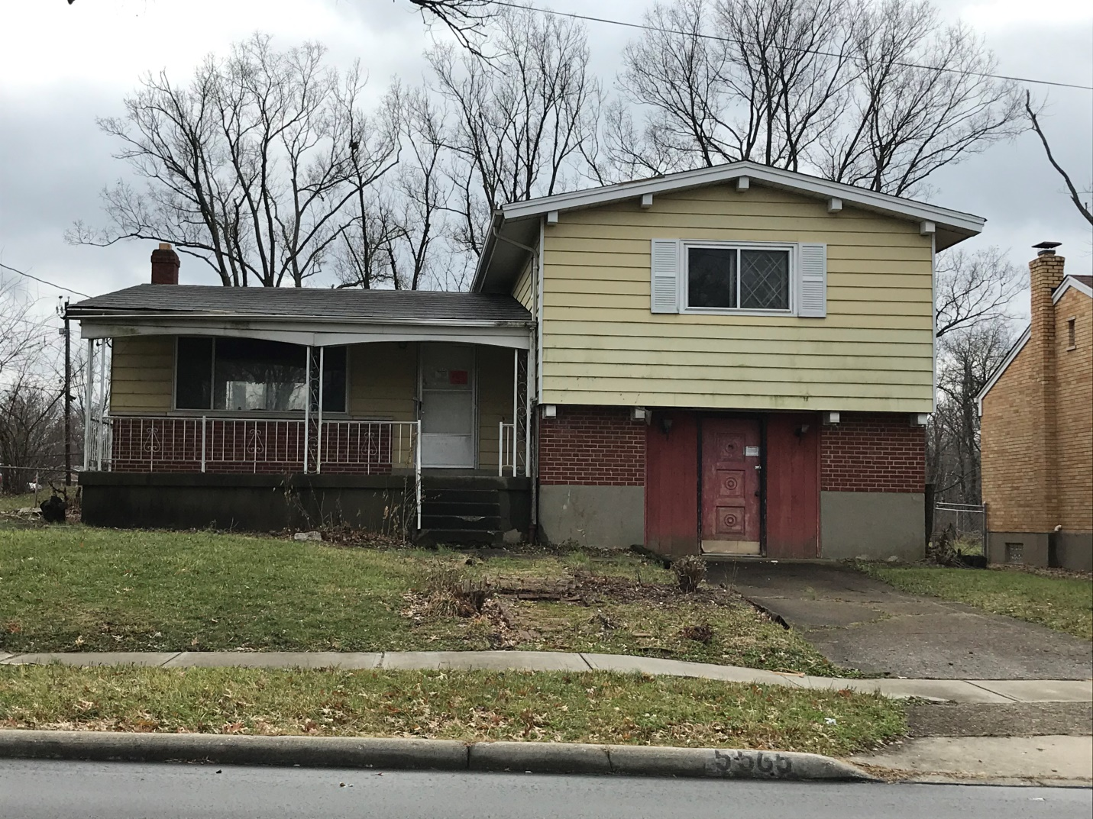

**Green Township Property Acquisition**

**Request for Qualifications**

**5565 Woodhaven Drive**

**APPLICANT INFORMATION**

1. Applicant Name:

1. Contact person, if applicant is a company or non-profit: ___________________________

3. Applicant Address:

4. E-mail: ___________________________________________

5. Phone: ________________________

**APPLICANT ELIGIBILITY**

In order to purchase property or take control of property for purposes of development or rehabilitation, an applicant must satisfy each of the following requirements. For purposes of this application, if the named applicant is an individual, then “Applicant” shall include the individual as well as any entity within which the applicant is a principal or a majority shareholder; if the Applicant is an entity, then “Applicant” shall include the entity as well as any individual that is a principal or majority shareholder of the entity.

By initialing each statement, the Applicant represents and warrants to Green Township that the corresponding statement is true and accurate:

1. Applicant will occupy the property for primary residence or sell it to another homeowner for their primary residence. Applicant will not rent the home for tenancy or sell to an investor to use for rental purposes. Applicant Initials: ____
2. The Applicant does not own any real property with outstanding orders for the violation of state and/or local property codes. Applicant Initials: ____
3. The Applicant does not have a history of owning real property in a chronic nuisance state, except if such state may be attributed solely to a prior owner. Applicant Initials: _____
4. The Applicant has not been the subject of criminal/civil prosecution for property maintenance code infractions within the last five years. Applicant Initials: _____
5. The Applicant does not own real property that is in a tax delinquent status.

Applicant Initials:____

1. The Applicant was not the owner of real property on which any foreclosure filing has been commenced within the last five years. Applicant Initials: ______
2. If the Applicant is an entity, then the entity is properly registered with the State of Ohio.

Applicant Initials: ______

1. Please list the addresses of all property in Hamilton County that the Applicant currently owns or has owned in the last three years:

_________________________________________________________________________

_________________________________________________________________________

_________________________________________________________________________

_________________________________________________________________________

_________________________________________________________________________

**­­­­­­­­­­­­­­­­­­­­­­­­SINGLE-FAMILY REHABILITATION**

**Basic Disposition Requirements:**

1. Applicant must have the capacity to undertake the rehabilitation of the property with a completion date of no later than **December 31, 2020**.
2. The Applicant must plan on rehabilitating a single-family structure, newly constructing a single-family home on a residential lot. The property must be maintained as an owner-occupied home for a minimum of 5 years. If Applicant is not going to occupy the home, the home must be sold to an owner-occupant within 6 months of completion or by June 30, 2021.

**General Terms of Sale:**

1. Purchase Price: Minimum sale price is $25,000.

What is the proposed purchase price for the property? ________________

1. Redevelopment Terms: All purchasers will be contractually required to develop the proposed project within specific time frames.
2. Maintenance: The purchaser must maintain the property during and after the redevelopment.
3. Property Taxes: The purchaser must agree to timely pay all property taxes that become due after the transfer.

YOUR EXPERIENCE

Tell us about your experience rehabbing or developing single-family properties. Include an attachment if you need more space.

Please include specific addresses, a description of projects, the type of tasks you have completed (roofing, hanging drywall, refinishing floors, etc.), and photographs of past projects if you have them. Did you pull permits for this work? If you have used or will use contractors rather than completing all the work yourself, tell us the scope of work for which you have hired or will hire contractors.

**HOME INSPECTION**

See home inspection report on page 7 for condition and required permits

**All bidders must attend one property walk through at the dates/times below:**

January14, 8 AM to 10 AM

January 16, 4 PM to 6 PM

**PROJECT SCHEDULE**

1. How long do you estimate the rehab to take? (Must be completed by December 31, 2020)
2. What variables may lengthen the process?
3. Who will perform the work?

Please list the names of any known or likely contractors or subcontractors, and their contact information, if you will not perform all the work yourself.

|  |  |  |
| --- | --- | --- |
| **Trade** | **Contractor** | **Phone** |
| Plumbing |  |  |
| Electric |  |  |
| Roof |  |  |
| HVAC |  |  |
| Carpenter |  |  |
| General Contractor |  |  |
| Windows |  |  |

Are you a licensed contractor or building inspector? ____ Yes ____ No

If yes, list license type(s), licensing board(s) and license number(s):

_____________________________________________________________________

_____________________________________________________________________

3. Cost and Financing of Project - Estimate your constructions costs in the table below:

| **Category** | **Minimum** | **Est Cost** | **Description** |
| --- | --- | --- | --- |
| Acquisition Price | $25,000 |  |  |
| Appliances | Replaced |  |  |
| Basement | Water proof? |  |  |
| Bathrooms |  |  |  |
| Cabinetry | Replaced |  |  |
| Carpet | Replaced |  |  |
| Countertops | Replaced |  |  |
| **Category** | **Minimum** | **Est Cost** | **Description** |
| Deck/Porch | Repaired or replaced |  |  |
| Demolition |  |  |  |
| Downspouts/Gutters |  |  |  |
| Drywall/Plaster |  |  |  |
| Electric Service | Upgraded or replaced |  |  |
| Exterior Doors |  |  |  |
| Exterior Painting |  |  |  |
| Fireplace Allowance |  |  |  |
| Flooring | replaced |  |  |
| Foundation | Repaired, sealed |  |  |
| Framing |  |  |  |
| Framing Materials |  |  |  |
| HVAC | Replaced |  |  |
| Insulation | Upgraded |  |  |
| Masonry/Concrete |  |  |  |
| Permit Fees |  |  |  |
| Plumbing | Replaced |  |  |
| Roofing | Repair to sheeting and replace roof |  |  |
| Siding, Soffits, Metal Work | Repair and replace |  |  |
| Termite Remediation |  |  |  |
| Water Heater | replaced |  |  |
| Windows | Replaced |  |  |
| **Total Cost** |  |  |  |

**Project Funding:**

* Include details about how you intend to finance the property rehabilitation.
* If you plan to already have funding in place, please provide proof of available funds.
* If you already have financing in place, attach your loan pre-approval letter.

|  |  |  |
| --- | --- | --- |
| **Funding Source** | **Amount** | **Is this funding secured? If yes, attach proof; if no, please add expected commitment date** |
|  | $ - |  |
|  | $ - |  |
|  | $ - |  |
|  | $ - |  |
|  | $ - |  |
|  | $ - |  |
|  | $ - |  |
|  | $ - |  |
| TOTAL | $ - |  |

**The undersigned agrees to the required terms of this application and attests that this application is submitted with proper authority and the information contained herein is true, accurate and complete.**

Applicant: _________________________

Print or Type Name: _______________________________ Date: ___________________

Signature: _______________________________________

**Submission:**

Please send completed applications EMAIL to: Fbirkenhauer@greentwp.org no later than 5 PM on February 7, 2020. Late submissions will not be considered.

# Inspection Report

# 5565 Woodhaven Drive, Green Township, Ohio 45247

This brick and block house was built in 1957, it is a multi- level style having approximately 1,900 square feet of living space with 3 bedrooms, 2 full baths, kitchen, dining room, living room, family room, partial basement and a 2-car garage.

The house has been vacant for 18 years and was not maintained or stabilized during this time.

**Overall**

* Plumbing in the house is cast iron with galvanized metal drains with copper supply lines
* Electric service is 100 amp and in need of replacement and/or upgrading
* Gas-forced air furnace is in disrepair and needs to be replaced
* Water heater needs to be replaced
* A/C unit is old and falling apart; it must be replaced
* Roof has leaked in areas for years and has been temporarily patched; it needs to be removed, sheeting accessed, repaired and replaced
* Interior of house has suffered water damage from the leaking roof
* Oak hardwood is warped and ruined throughout the house
* Flooring cannot be repaired; it needs to be removed and replaced

**Kitchen**

* Kitchen cabinets are in poor shape and original to the house
* Counter tops are Formica and in poor condition in need of replacement
* There are no appliances except a built-in electric oven that is antiquated, and needs replaced
* Subfloor has been damaged from the roof leaking and needs to be repaired or replaced before finish floor can be installed.

**Plumbing**

* All plumbing fixtures and faucets need replacement because of the age and that they have been unused for so long the seals would be bad and not cost effective to repair.
* All the cast iron and metal drain lines should be cut out and replace with PVC schedule 40 piping.
* The main drain to the street should be camera’d and rodded out, when houses sit unused such as this one the drainage gets stopped up and needs to be cleared.

**Windows**

* The windows are not original to the house but are older vinyl windows and no longer efficient and should be replaced.

**Insulation**

* The insulation throughout the house is non- existent because the nature of construction leaves no wall cavities to be insulated. The attic space appears to have very little if any insulation.

**Bathrooms**

* The common full bath walls are laminated with vinyl sided paneling and needs to be removed
* the wall board underneath needs to be replaced or refinished,
* the tub surround needs to have wonder board and ceramic tile to water proof the tub area.
* The floor area similarly addressed accordingly.

**Family Room**

* The family room has paneled walls and they show evidence of termite damage, the extent of the damage is to be determined in the demolition stage of the remodel.
* It is not determined if they are gone or still active, that room has a concrete slab as the floor and its most probably where the termites came from, the ground under the concrete.

**Master Bathroom**

* The master bath seems to be in decent condition, the ceramic can be saved but the toilet and the vanity sink needs replaced.
* All the walls throughout need to be refinished and paneling removed throughout.
* Holes are in the ceiling from water damage and need to be repaired and refinished.
* Light fixtures throughout need replaced.

**Garage**

* Currently the garage has been used as living space with removal of the garage door and framed in to accept a 3’ man door; this space has been converted illegally and not code complaint.

**Exterior Concrete**

* The exterior concrete walks and steps have settled and spalled causing unsafe riser differences and can only be fixed by removal and replacement.

**Permits**

Permits are required for the work below; appropriate agency is listed as well:

* Replacement of the HVAC system – Hamilton County Planning + Development
* Replacement of roof – Hamilton County Planning + Development
* Replacement of the plumbing + piping – Hamilton County Planning + Development
* Replacement of water heater - Hamilton County Health Department Plumbing Division
* Electrical work and replacement – IBI (the Inspection Bureau, Inc.)